Revel Data Connector is the way to access Revel point-of-sale (POS) core data using business intelligence (BI) tools to provide visibility and transparency. Revel Data Connector aims to solve descriptive and diagnostic analytics problems, such as liabilities, service fees, customer dining options, etc. and may be used as a foundation for other types of analysis

RDC is available to U.S. and international customers, as well as enterprise and non-enterprise customers. You can access a completely free trial of RDC, provided with demo data, that lets you use a BI tool of your choice to check what kind of data you will get access to after purchasing RDC, how it will work, if it meets your needs, etc.

To access your free trial or to purchase Revel Data Connector, reach out to your customer success manager or Revel customer support!

Additionally, you can find setup and use information, plus FAQ, in our [Developer Portal.](https://developer.revelsystems.com/revelsystems/docs/about-revel-data-connector)

### **Contents**

* Functionality
* Connecting to a Business Intelligence Tool

### **Functionality**

Revel Data Connector allows you to access your POS data using a business intelligence (BI) tool, through which you can then create custom dashboards/reports and answer your business questions using SQL queries. Essentially, RDC is an AWS Redshift database with your data conveniently stored and hosted by Revel.

RDC has extensive data about orders, order items, modifiers, payments, labor, employees, POS stations, liabilities, service fees, and many more. You can take a look at our data dictionary to get an understanding of what data can be accessed with RDC. In the future, we are planning to add more speed of service, inventory, and labor data.

RDC has been **tested** with Looker, Power BI, Tableau, Dbeaver, and is confirmed to be working well with them. However, you should be able to connect and use RDC with any other BI tool of your choice, which would have the option of connecting data from an AWS Redshift data connector (e.g. Microsoft Dynamics, Sisense, Qlik Sense, Oracle, etc).

**Note**: Revel Data Connector has a 25K row limit when querying data.

### **Connecting to a Business Intelligence tool?**

The Revel Data Connector solution is universal, and it should work with all the BI tools. Below you can find instructions on connecting to the most common BI tools: Power BI & Google Data Studio.

#### **Power BI**

**Note**: The instructions provided below are for the desktop version of Power BI.

##### **Step 1: Get Data**

To connect to an **Amazon Redshift** database, select **Get data** from the **Home** ribbon in Power BI Desktop. Select **Database** from the categories on the left, and you will see **Amazon Redshift**: 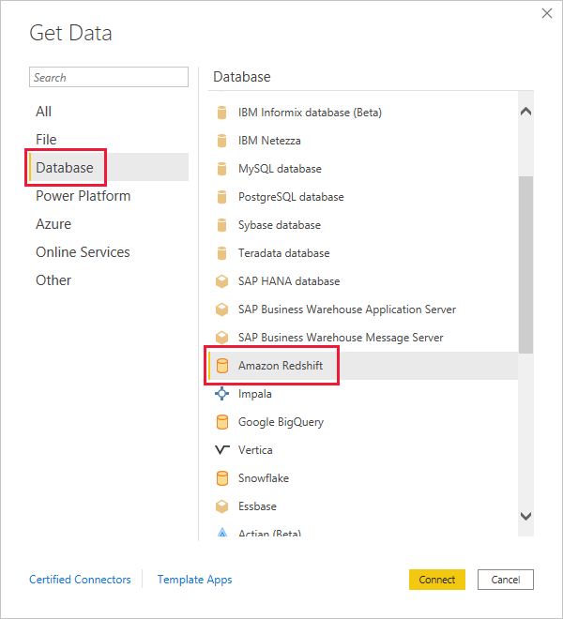

##### **Step 2: Server and Database Info**

In the **Amazon Redshift** window that appears, type or paste the name of your **Amazon Redshift** server and database into the box. As part of the Server field, you can specify a port in the following format: ServerURL:Port. 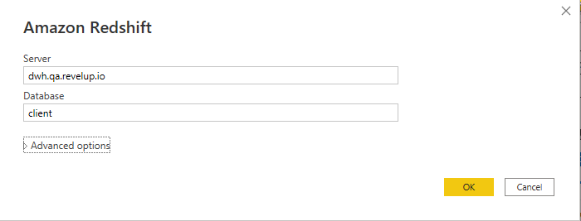

##### **Step 3: Credentials**

When prompted, put in your username and password. You should use the server name that precisely matches the SSL certificate to avoid errors: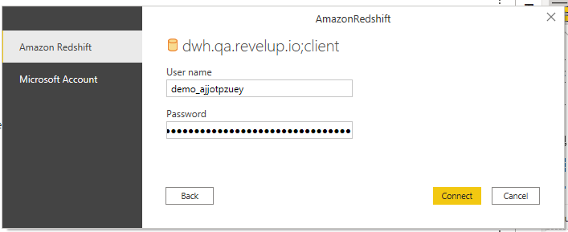

##### **Step 4: Connection Settings**

After clicking **Connect,** you might encounter the following error. If you don't see this error and you're redirected to the **Navigator** view, skip this step and jump to Step 5: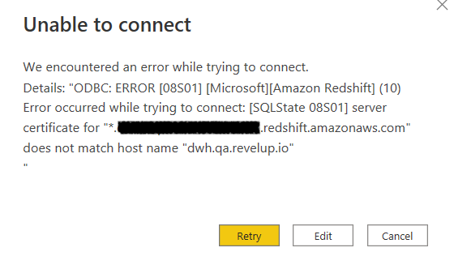

This is expected, as PowerBI's default configuration includes the custom DNS hostname verification as a part of the encrypted connection checks.

In order to mitigate the error, go to **File** > **Options and settings** > **Data source settings**: 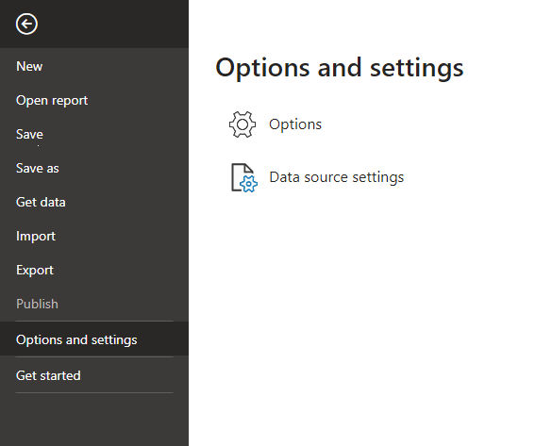

In the list of data sources, select the data source which was recently configured (e.g. dwh.revelup.io) and click **Edit Permissions**: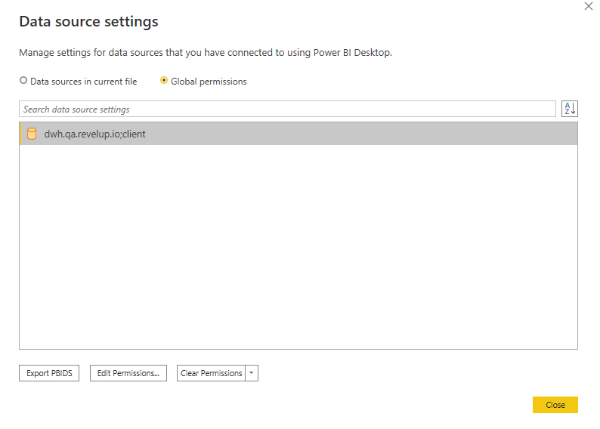

##### **Important Note:**

Revel is still enforcing the appropriate security level by forcing an encrypted connection and verifying the SSL certificate from the server-side. We also use a custom domain to provide you with a better experience and prevent unnecessary connection string modifications after performing server maintenance.

Uncheck **Encrypt Connections** and click **OK**: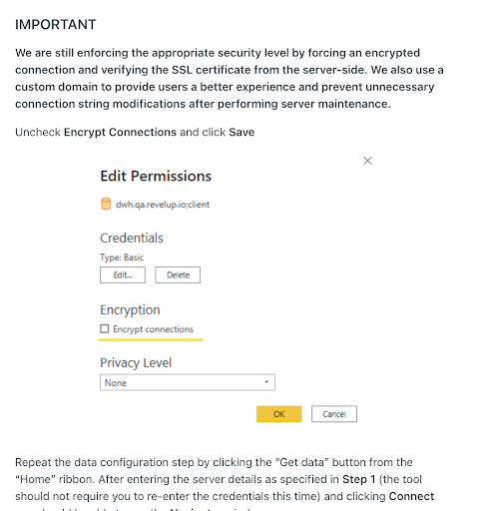

Repeat the data configuration step by clicking the **Get data** button from the **Home** ribbon. After entering the server details as specified in Step 1 (the tool should not require you to re-enter the credentials this time) and clicking **Connect**, you should be able to see the **Navigator** window.

##### **Step 5: Navigator**

Once you successfully connect, a **Navigator** window appears and displays the data available on the server, from which you can select one or multiple elements to import and use in **Power BI Desktop:** 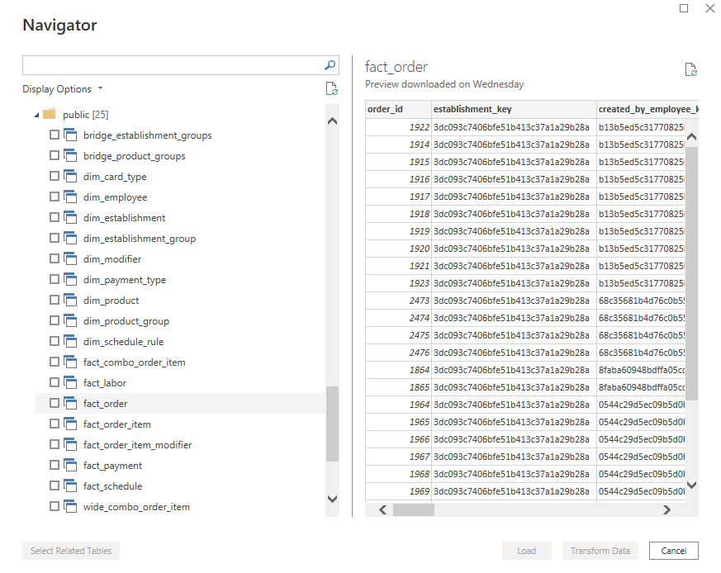

##### **Step 6: Loading or Transforming the Data**

Once you make selections from the **Navigator** window, you can either **Load** or **Transform** the data.

* If you choose to **Load** data, you'll be prompted to use either **Import** or **DirectQuery** mode to load the data.
* If you select to **Transform** data, **Power Query Editor** appears where you can apply all sorts of transformations and filters to the data, many of which are applied to the underlying **Amazon Redshift** database itself (if supported).

#### **Google Data Studio**

##### **Step 1: Get Data**

To connect to an **Amazon Redshift Connector**, click on **Blank Report** in the landing page. Search for **Amazon Redshift**, and you will see it in the Google Connectors section. Select it: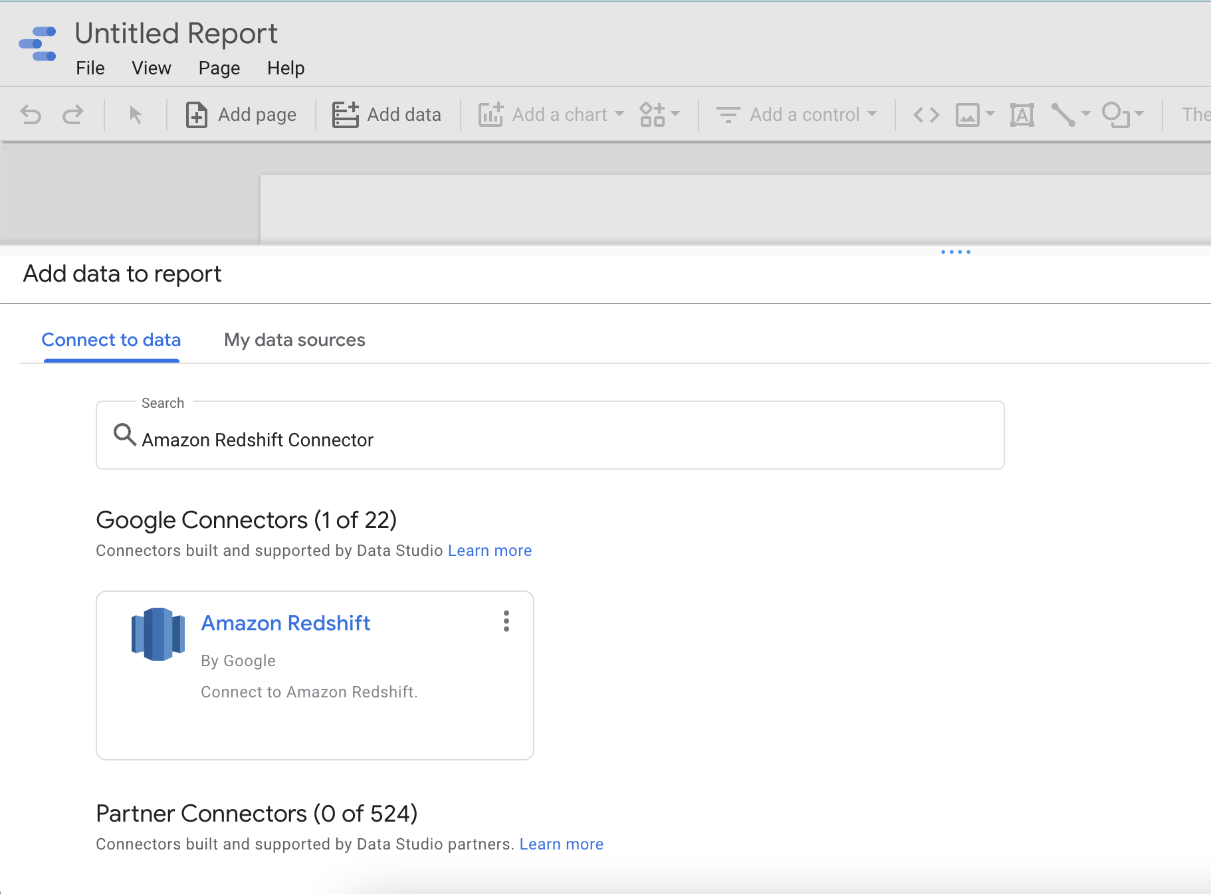

##### **Step 2: Database Authentication**

In the **Amazon Redshift** window that appears, type or paste the name of your **Amazon Redshift** host name, port, database, username and password. Click **Authenticate**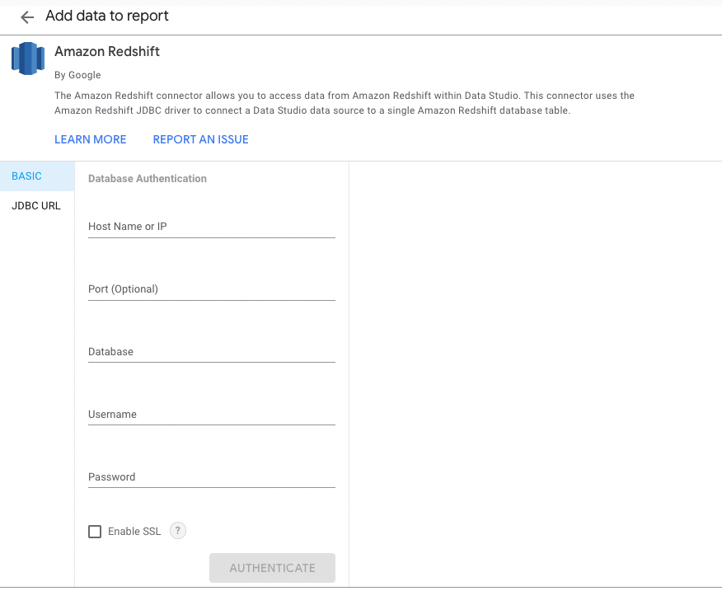

##### **Step 3: Loading the Data**

Select **Table** or enter **Customer Query** and Click **Add**.

A modal pops up to confirm. Click on **Add to Report**.